Skyrim Gwent:

Factions count : 2

Hero Cards count : 2 (One per faction)

Total Unit Cards: 42 around

Special Cards : 7

Battlefield:

3 Zones:

**Zone 1 : Frontlines**

Place Melee / Close Combat cards and / or spellswords on the frontlines of Battlefield

Buffs: Healing hands, Scroll of healing will buff all cards in this zone

Weakness: Frostbite and extreme cold weather affects all cards on this zone

**Zone 2 : Vantage**

Place Pure Mages cards and / or spell swords on this zone.

Buffs: Restore Magicka,

Weakness: Magicka Drain, Magicka Block [Bane Aetherius]will affect all cards on this zone

**Zone 3: Shadow**

Place Assassin / Thief / Archer cards on Shadow Zone. Archers attack from long range, assassins and thieves can work incognito on the battlefield.

Buffs: Cloak, Mist, Fog, Illusion cards will buff all cards in this zone

Weakness: Reveal, Enlighten, Sun Fire Special Cards will affect all cards in this zone

Types of Units:

There are 4 types of basic unit cards:

1) Warrior:



Close combat cards can be placed on Frontlines only.

Subcategories:

i) Light Armor:

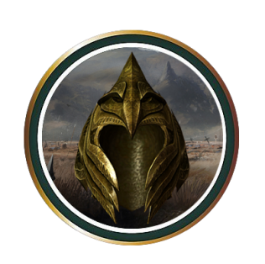

Light Armor means light on your feet. But it also provides less protection against damage. Light armored Units will be set to strength 1 when affected by Frostbite.

ii) Heavy Armor:

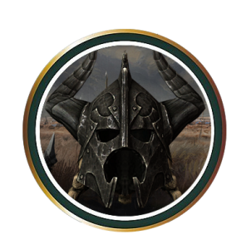

Heavy armored units get more protection then light armored. Heavy armored units will be set to strength 2 when affected by Frostbite (if their base strength was above 2, otherwise will remain unchanged.)

2) Mage:

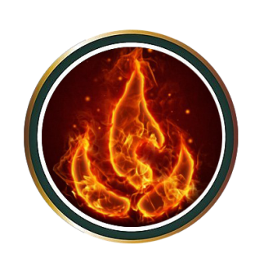

Mage cards can be placed on Vantage only.

Subcategories:

i) Pyro

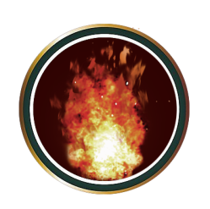

Pyromancers use the element of fire to deal damage.

ii) Frost

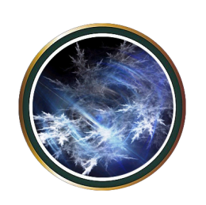

Cyromancers use the element of ice to deal damage.

iii) Sparks

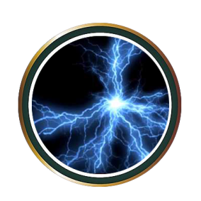

Electromancers use the power of electricity to deal damage.

iv) Necromancers:

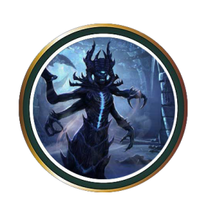

Necromancers can either summon an undead or resurrect an eliminated card on their own side. Resurrection duration depends on Unit skill (2 rounds, 4 rounds, Permanent).

v) Conjurers:

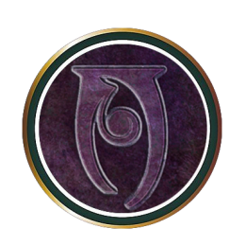

Conjurers specialize in summon creatures from Oblivion. Most conjurers may have low strength on their own. However depending on their level they can summon creatures from Oblivion. These creatures can be instantly placed on the battlefield regardless if they exist in the faction deck or not. Banish Daedra spell cards will eliminate conjured creatures.

3) Spellswords:

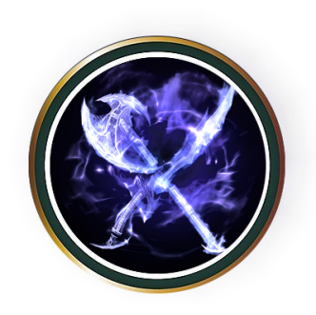

Spellswords mix their combat both with melee weapons and magic. These units can be deployed on either Frontlines or Vantage. Will be affected by any buffs or de-buffs on the respective row if any. Cannot Change position after being deployed unless a special card is used. Spellswords may specialize in individual school of magic. However they cannot use the magic school special abilities.

4) Shadow

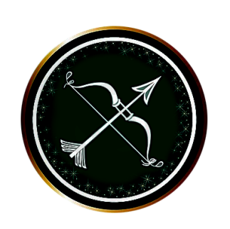

Units in the Shadow zone are Archers, Thieves and Assassins who work from a distance and in the shadows. Archers can attack either from the shadows or long range. Assassins and Thieves can work on the enemy lines. These units can be only placed in the shadow Zone.

Subcategories:

i) Archers:

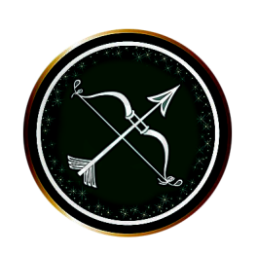

Archers can stealthily kill enemies through the shadows.

ii) Thieves:



Thieves work differently than the other units. They will not always engage the enemy directly but manipulate them by bribing, stealing intel, sabotaging, etc.

iii) Assassins

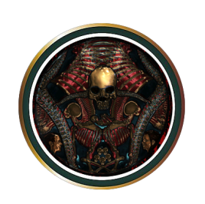

Coldblooded murderers. Work in the shadows and behind enemy lines if necessary. Some units have the assassination ability.

Additional:

i) Spy Units:

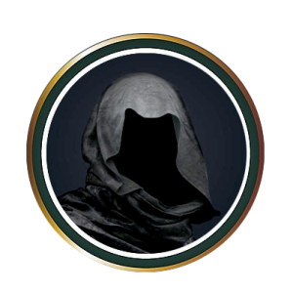

Spies work very differently than all other units. Spies are disguised and place on the enemy side. Though their strength will contribute against to the enemy's total, it allows you to re-draw two cards from deck.

ii) Vampires:

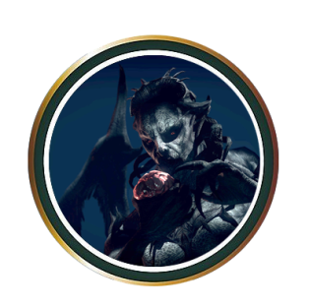

Vampires are creatures of the night. They use magic. However a vampire can be choose any style of combat. Volkihar Vampire Faction gets bonuses for their vampire units.

Blood Magic:

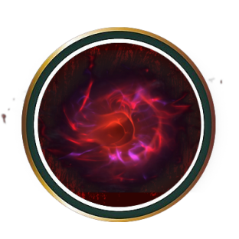

Vampires have access to their unique Blood magic school which cannot be de-buffed like other magic schools.

iii) Units versed in Thu'um:



Certain Units have mastered atleast one shout of the dragon language and can use it in battle. If they master in multiple shouts, they can choose the shout they desire. This ability will count as the 'Single Master Ability'.

iv) undead category ??

Factions:

Whiterun (DONE)

Thieves Guild (DONE)

Dark Brotherhood

Imperials

Stormcloaks

College Of Winterhold

Volkihar

Dawnguard

Orsimer

Dwarwen